1. Buatlah projek menggunakan platform Blynk untuk mengendalikan 3 buah led dengan input Switch.
2. Buatlah projek menggunakan platform Blynk untuk mengatur tingkat kecerahan Led (output PWM = 0-255) menggunakan input Slider.

|  |  |  |
| --- | --- | --- |
| NO | Nilai pada Slider | Kondisi kecerahan LED |
| 1. | 0 | Mati |
| 2. | 50 | Redup |
| 3. | 100 | Terang |
| 4. | 150 | Lumayan Terang |
| 5. | 200 | Sangat Terang |
| 6. | 255 | Terang Maksimal |

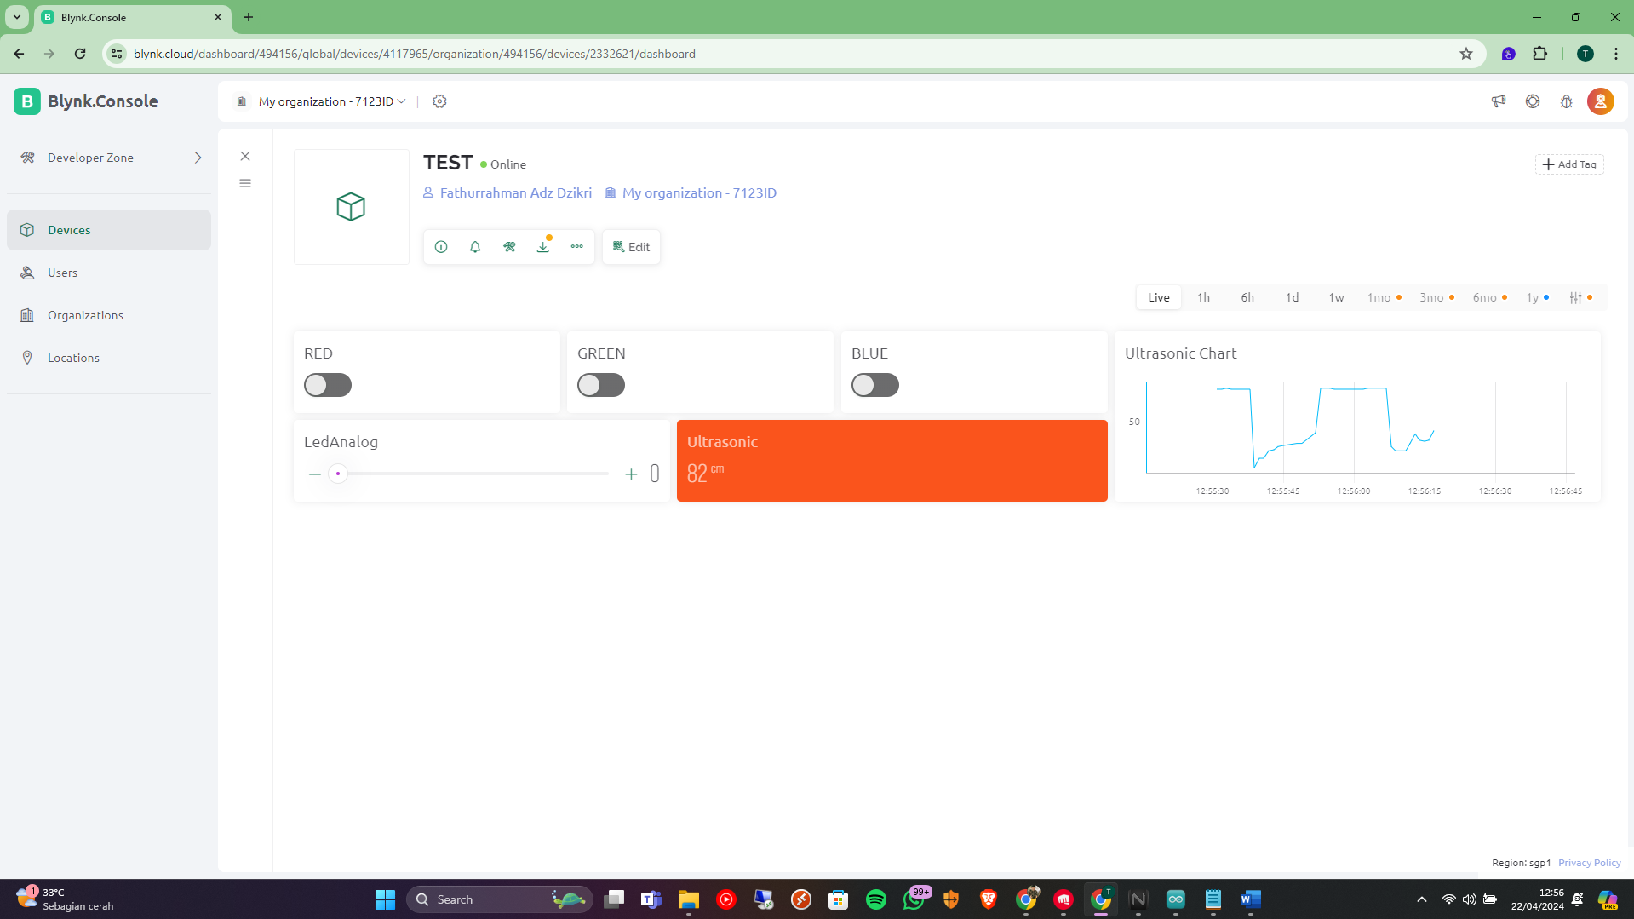

|  |  |  |  |
| --- | --- | --- | --- |
| No | Switch | Kondisi Switch | Kondisi Led |
| 1. | Switch 1 | ON | Nyala |
| OFF | Mati |
| 2. | Switch 2 | ON | Nyala |
| OFF | Mati |
| 3. | Switch 3 | ON | Nyala |
| OFF | Mati |

#include <WiFi.h>

#include <WifiClient.h>

#define BLYNK_TEMPLATE_ID "TMPL6loBsuyT2"

#define BLYNK_TEMPLATE_NAME "aoe8w"

#include <BlynkSimpleEsp32.h>

char ssid[] = "p";

char pass[] = "pake nanya";

char auth[] = "cLrYmvTYv5E3xJHDX1eI1Vte6n8aTht5";

#define RED 25

#define GREEN 33

#define BLUE 32

#define LEDAnalog 26

#define echo 14

#define trig 27

#define VirtualLabel V4

BlynkTimer timer;

long duration, distance; // Variables to store duration and distance

void setup() {

  // put your setup code here, to run once:

  Serial.begin(9600);

  WiFi.begin(ssid, pass);

  while (WiFi.status() != WL_CONNECTED){

    delay(500);

    Serial.println("Connecting to WiFi..");

  }

  Serial.println("Connected to WiFi");

  Blynk.begin(auth, ssid, pass);

  pinMode(RED, OUTPUT);

  pinMode(GREEN, OUTPUT);

  pinMode(BLUE, OUTPUT);

  pinMode(LEDAnalog, OUTPUT);

  pinMode(trig, OUTPUT);

  pinMode(echo, INPUT);

  timer.setInterval(500L, readSensor);

}

void loop() {

  // put your main code here, to run repeatedly:

  Blynk.run();

  timer.run();

}

BLYNK_WRITE(V0){

  int pinValue = param.asInt();

  if(pinValue == 1){

    digitalWrite(RED, HIGH);

    Serial.println("LED RED ON");

  } else {

    digitalWrite(RED, LOW);

    Serial.println("LED RED OFF");

  }

}

BLYNK_WRITE(V1){

  int pinValue = param.asInt();

  if(pinValue == 1){

    digitalWrite(GREEN, HIGH);

    Serial.println("LED GREEN ON");

  } else {

    digitalWrite(GREEN, LOW);

    Serial.println("LED GREEN OFF");

  }

}

BLYNK_WRITE(V2){

  int pinValue = param.asInt();

  if(pinValue == 1){

    digitalWrite(BLUE, HIGH);

    Serial.println("LED BLUE ON");

  } else {

    digitalWrite(BLUE, LOW);

    Serial.println("LED BLUE OFF");

  }

}

BLYNK_WRITE(V3){

  int pinValue = param.asInt();

  analogWrite(LEDAnalog, pinValue);

}

void readSensor() {

  digitalWrite(trig, LOW);

  delayMicroseconds(2);

  digitalWrite(trig, HIGH);

  delayMicroseconds(10);

  digitalWrite(trig, LOW);

  duration = pulseIn(echo, HIGH);

  distance = duration * 0.034 / 2;

  if (distance >= 200 || distance <= 0) {

    Serial.println("Out of range");

  } else {

    Serial.print("Distance: ");

    Serial.print(distance);

    Serial.println(" cm");

  }

  Blynk.virtualWrite(VirtualLabel, distance);

}